**ICS Website Redesign**

**Team Event Horizon:**

April Huie

Celine Deleon

Chanelle Hojberg

Eric Tran

Juston Lin

**Requirements Draft #1**

**October 19, 2017**

# TABLE OF CONTENTS

**REVISION HISTORY** **3**

**STATEMENT OF WORK** **3**

**ASSUMPTIONS** **4**

**PERSONAS & SCENARIOS** **5**

Prospective Undergraduate Student - Freshman 5

Prospective Undergraduate Student - Transfer 6

Undergraduate Student 7

Prospective Graduate Student 8

Graduate Student 8

Faculty Member 9

Prospective Faculty Member 10

Alumni / Donors 10

Project Sponsors / Outside Research Stakeholders 11

**REQUIREMENTS** **12**

FUNCTIONAL REQUIREMENTS 12

Must Haves (#1) 12

Nice to Have (#2) 12

Great if We Can Get It (#3) 12

NON-FUNCTIONAL REQUIREMENTS 12

**USER STORIES** **13**

# REVISION HISTORY

* **10/9/2017:**
  + Document initial functional and nonfunctional requirements
  + Decide on types of personas and scenarios
* **10/11/2017:**
  + Confirm requirements and personas with Matt and ICS Website Taskforce Committee
* **10/12/2017:**
  + Create and decide on a consistent format for persona diagrams
* **10/16/2017:**
  + Create a Table of Contents
  + Format the “Requirements Draft #1” Document
  + Add in “Revision History”, “Statement of Work” and “Assumptions” sections
  + Produce rough sketches of the front page of the website
* **10/18/2017:**
  + Include User Stories
  + Include finalized personas and scenarios
  + Complete Statement of Work
  + Complete Assumptions

# STATEMENT OF WORK

Team Event Horizon is working with sponsor Matt Miller and the ICS Website Taskforce Committee to redesign the ICS departmental website. Currently the website is not scalable for all types of devices, and it is organized in such a way that the screen is overwhelming and composed of mostly text and nested pages, making it complicated to navigate. Thus, our goal is to create a new design so that the website is updated, responsive, easy to navigate, and easy to maintain.

At the beginning of the quarter, Team Event Horizon had an initial meeting to discuss individual differences and similarities, strengths and weaknesses, as well as prepare questions to ask Matt. At the first meeting with Matt and the ICS Website Taskforce Committee, we were able to discuss expectations regarding deliverables, requirements, and resources. We met again to discuss design ideas and decided to closely refer to the University of Texas at Austin Computer Science Department website since that is what the head of our ICS department saw as an ideal design. Our next meeting was to confirm requirements and personas, which we based our user stories on. Our team has individually produced rough sketches of design ideas for the layout of the website, and as of Friday, October 13 Matt was able to grant us access to WordPress as a sandbox to experiment with.

In the near future, Team Event Horizon plans to meet with Matt and the ICS Website Taskforce Committee to discuss proposed design ideas. Then we will be able to create more detailed sketches and eventually a mock-up of the full design. Now that we are able to familiarize ourselves with and use WordPress, we will be able to produce a live and working prototype of the redesigned website once our proposed iterations are approved so that Matt and the ICS Website Taskforce Committee can better visualize our design. If time permits, we can even meet with Matt again after creating a WordPress prototype to discuss navigation and the experience design.

Based on our meetings and progress thus far, the main deliverables expected from Team Event Horizon include rough sketches of the initial design, mock-ups of the home page as well as content pages, and a WordPress prototype. In order to achieve these goals we have completed our own individual rough sketches of design ideas, and we will meet to confirm a skeleton design by the end of Week 4. Then we aim to generate the mock-ups by the end of Week 6, iterate and obtain approval by the end of Week 7, and construct the WordPress prototype by the end of Week 9. Last minute changes and final touches will be implemented by the end of Week 10.

# ASSUMPTIONS

* Design only, little/no coding involved
* Assume use of website by undergraduate students based on our own experiences
* WordPress implements responsive design
* We will also reorganize content so that it is less overwhelming and more readable

# 

# 

# PERSONAS & SCENARIOS

#### Prospective Undergraduate Student - Freshman

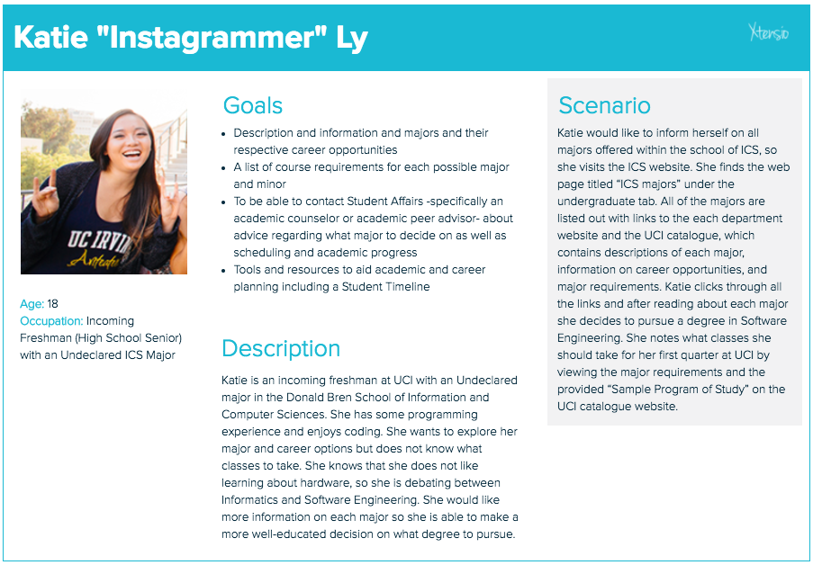

#### Prospective Undergraduate Student - Transfer

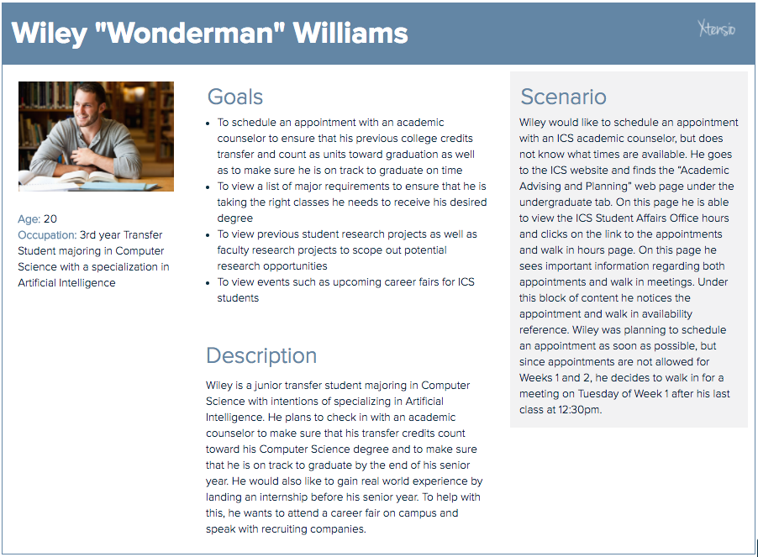

#### Undergraduate Student

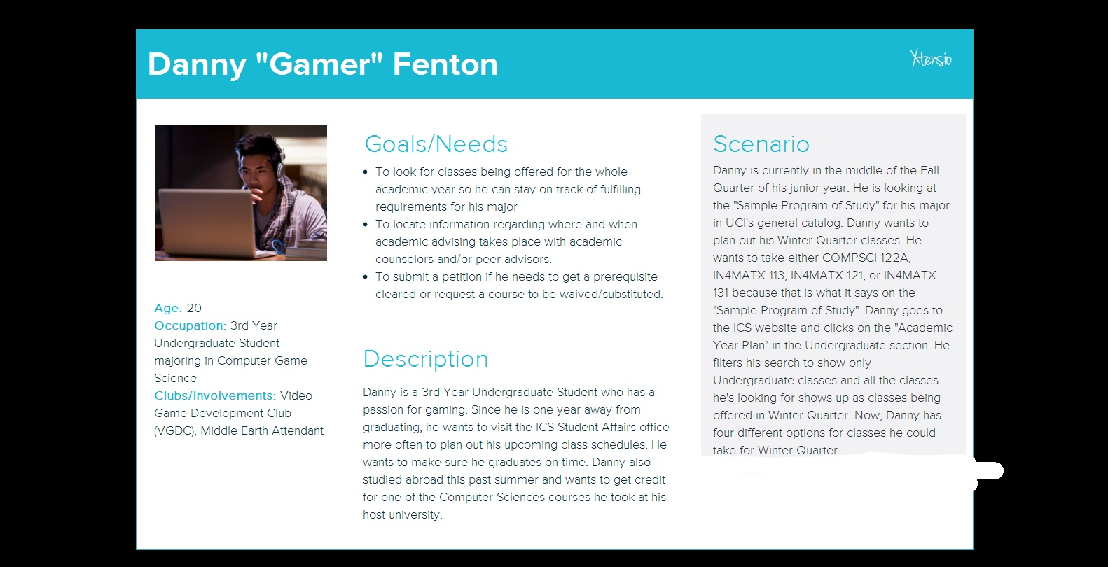

#### Prospective Graduate Student

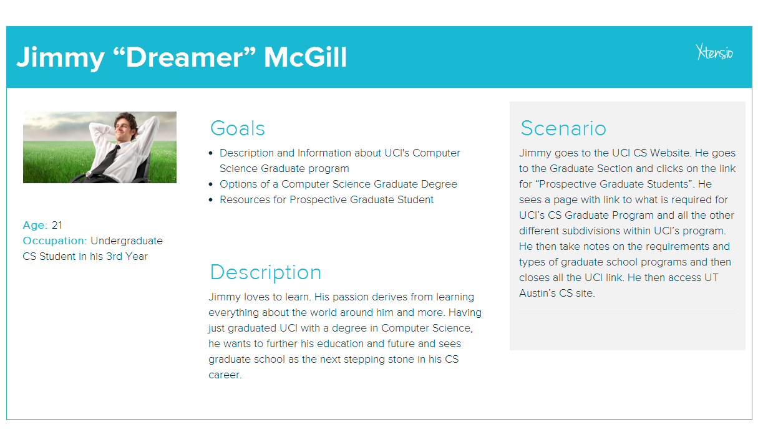

#### Graduate Student

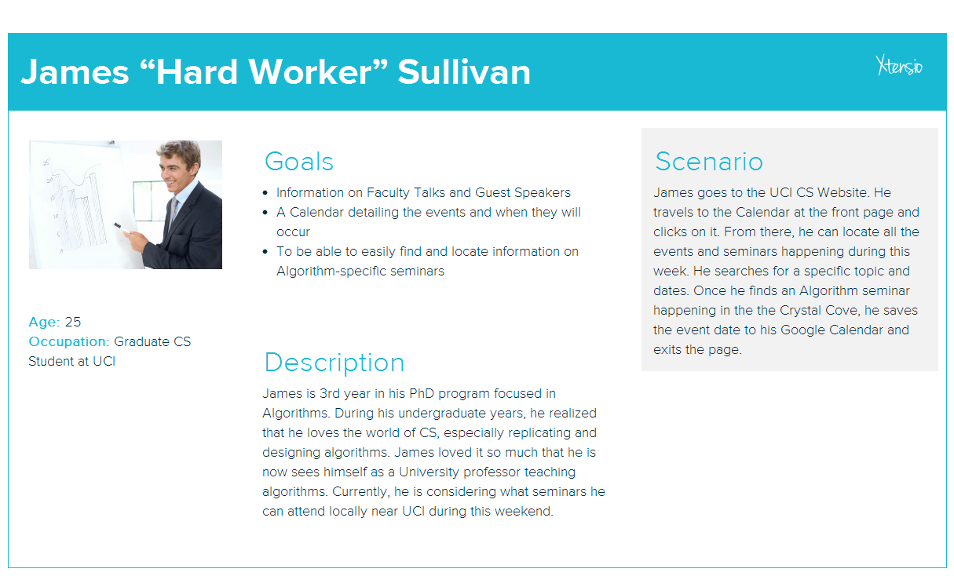

#### Faculty Member

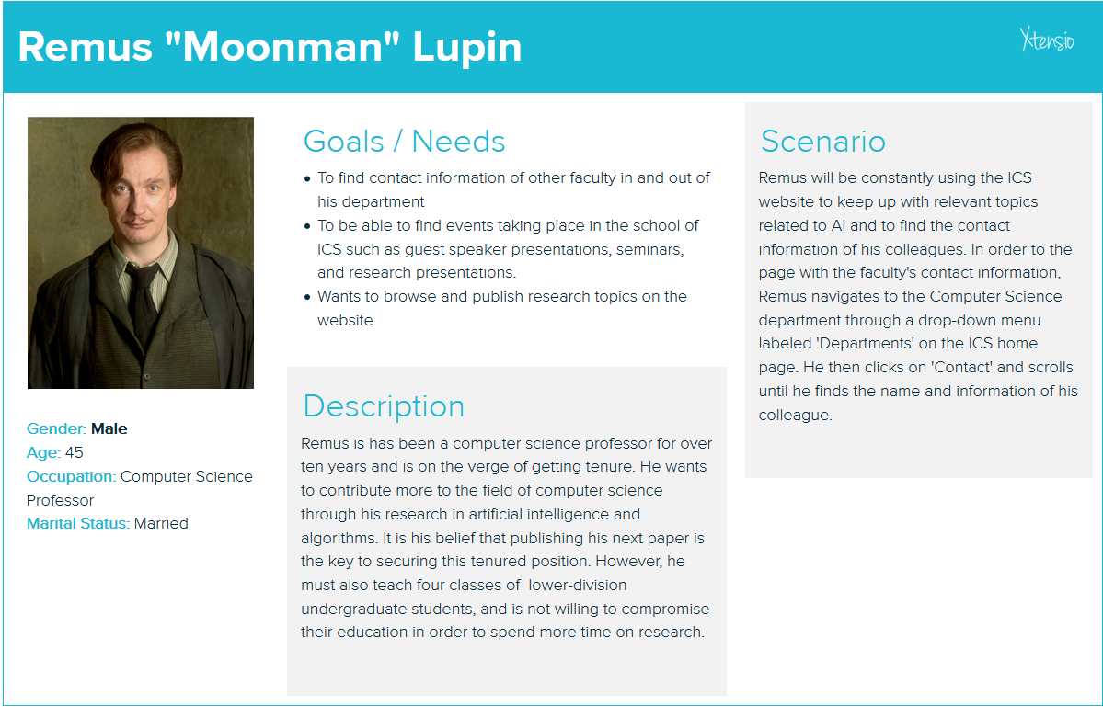

#### Prospective Faculty Member

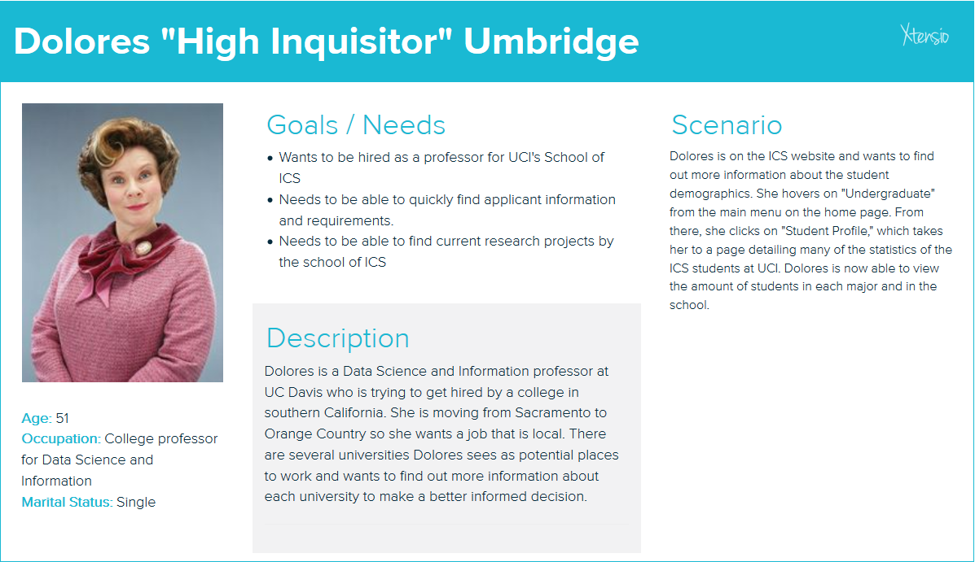

#### Alumni / Donors

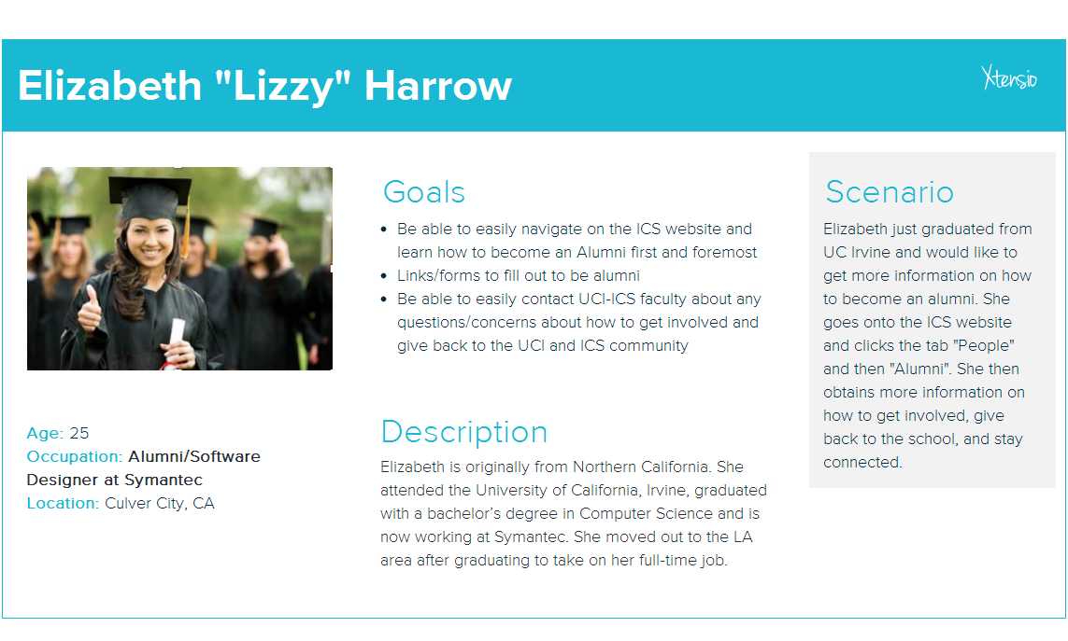

#### Project Sponsors / Outside Research Stakeholders

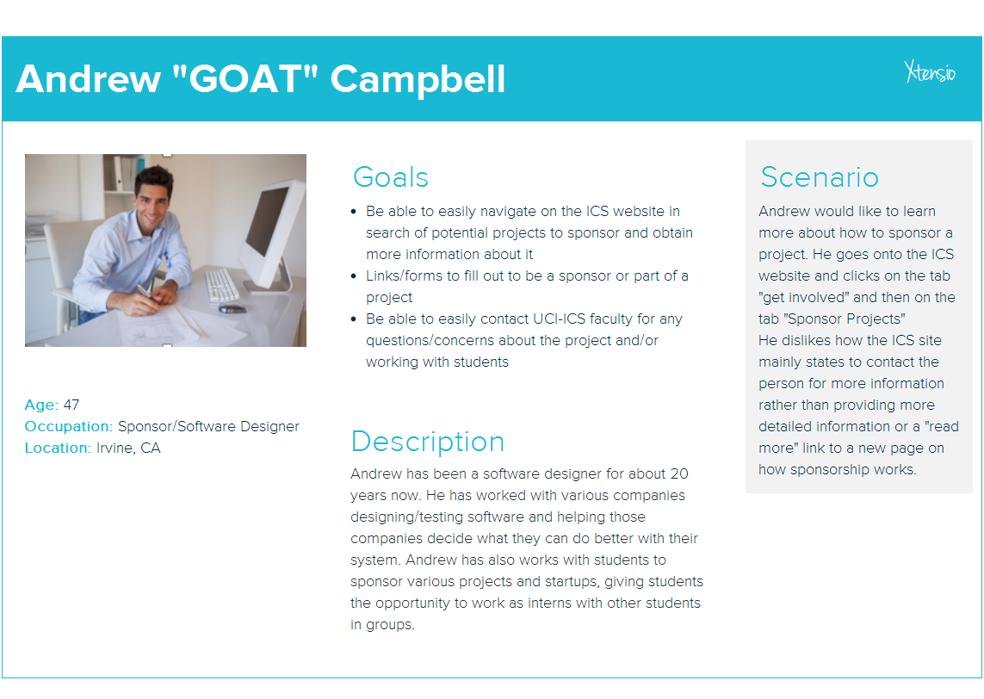

# 

# 

# REQUIREMENTS

## FUNCTIONAL REQUIREMENTS

### Must Haves (#1)

* Display Navigation Menu (possibly using nested menus)
  + Graduate
  + Undergraduate
  + Faculty
* Calendar
  + On the side
  + Easy to see and access
* Events
* Highlight Research
  + Faculty research
* Social Media
  + Links on the bottom
  + Slideshow
* Background picture
* Responsive design (readable on all types of devices)
  + Mobile Mockup

### Nice to Have (#2)

* Fix the search bar
* Update faculty directory
* Have information dynamically updated

### Great if We Can Get It (#3)

* Surveys // research // background on what others might want to see on the website (If design completed)

## NON-FUNCTIONAL REQUIREMENTS

* Accessibility
  + Make sure the website is ok for color-blind folks
  + Videos have subtitle option
* Usability
  + The user should be able to navigate through the website using multiple devices, such as a laptop, a tablet, or a smartphone.
  + Intuitive to use and easy to learn
  + Easy to navigate
* Maintainability
  + Easy to maintain -- A staff member with no web design or coding experience should be able to make changes to the website.
* Scalability
* Security
* Extensibility

# USER STORIES

* As an undergraduate student, I want to look up classes being offered during the academic year so that I can plan out my classes for the year.
* As an undergraduate student, I want to figure out how to get advising on classes and my future career path so that I can make sure I graduate and meet my career goals.
* As a project sponsor, I want to look up research projects so that I sponsor a project with students.
* As a graduate student, I want to look up different doctorate degrees being offered so that I can choose the right PhD program that matches my interests.
* As a graduate student, I want to search for possible internships and research opportunities so that I can gain more experience in my field of study.
* As an alumni, I want to look up how to give back to the school so that I can be more involved after graduation.
* As an undergraduate student, I want to look up events such as upcoming career fairs, workshops, meetups, and technical talks, so that I can network with industry professionals and meet my career goals.
* As an undecided undergraduate student who isn’t sure of my field of study, I want to be able to easily look up and compare the course requirements of different majors.
* As a faculty member, I want to easily navigate through the ICS website so that I can maintain the faculty directory and make possible revisions.
* As an undergraduate student, I want to contact the ICS Student Affairs Office so that I can schedule an appointment with an academic counselor or go in for walk-in hours.
* As a prospective faculty member, I want to be able to look into faculty recruitment so that I can learn more about the school,its culture, and what it has to offer.
* As an undergraduate Informatics student, I want to learn about the different fields and specializations and how I can apply what I’m learning in class, to the industry.